SASK FIRST ELITE ATHLETE PROGRAM APPLICATION

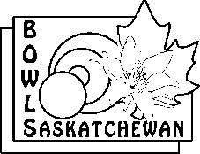 | Bowls Saskatchewan Inc.  1734 Elphinstone St. Regina, SK S4T 1K1  Phone: (306) 780-9426 / Fax: 781-6021  bowlsask@sasktel.net

Date

Name
Address |  | Street
 |  | City |  | Postal Code:
Home Phone # |  |  | Work #
Email
Fax #

Home Club |  |  | Coach |  |  | # yrs bowling
Lawn Bowling Involvement  (Previous Year) | □ Club Executive  □ Club Committee | □ Provincial Executive  □ Provincial Committee |  | □ National Executive  □ National Committee | □ Coach  Level __________  □ Official
 | Other involvement

Comments

In the next section: Please circle and add only the HIGHEST LEVEL achieved each year for sections A, B, C and D.
Provincial Playdowns
The athlete finishes in: | Name of event: | 20__ | 20__ | 20__ | Total
bronze medal at a tier 1 event |  | 8 | 8 | 8
silver medal at a tier 1 event |  | 12 | 12 | 12
gold medal at a tier 1 event |  | 16 | 16 | 16
bronze medal at a tier 2 event |  | 5 | 5 | 5
silver medal at a tier 2 event |  | 7.5 | 7.5 | 7.5
gold medal at a tier 2 event |  | 10 | 10 | 10
TOTAL

Canadian Championships
The athlete finishes in: | Name of event: | 20__ | 20__ | 20__ | Total
4th place at a tier 1 event |  | 4 | 4 | 4
bronze medal at a tier 1 event |  | 8 | 8 | 8
silver medal at a tier 1 event |  | 12 | 12 | 12
gold medal at a tier 1 event |  | 16 | 16 | 16
4th place at a tier 2 event |  | 2.5 | 2.5 | 2.5
bronze medal at a tier 2 event |  | 5 | 5 | 5
silver medal at a tier 2 event |  | 7.5 | 7.5 | 7.5
gold medal at a tier 2 event |  | 10 | 10 | 10
TOTAL

Bowls Sask (Out of Province) SANCTIONED TOURNAMENTS
Tournament Record Card MUST have been submitted to receive credit | 20__ | 20__ | 20__ | Total
The athlete wins the championship flight of a tournament | 5 | 5 | 5
The athlete finishes 2nd in the championship flight of a tournament | 3 | 3 | 3
The athlete finishes 3rd in the championship flight of a tournament | 1 | 1 | 1
The athlete wins any flight of a tournament with only 1 loss | 1 | 1 | 1
TOTAL

National Team Competitions (excludes North American Challenge – NAC)***
The athlete finishes in: | Name of event: | 20__ | 20__ | 20__ | total
4th place at an international event |  | 2 | 2 | 2
bronze medal at an international event |  | 4 | 4 | 4
silver medal at an international event |  | 6 | 6 | 6
gold medal at an international event |  | 8 | 8 | 8
TOTAL
*** If an athlete medals in multiple international events in the same year, they will receive points for each event.
Total of all for each year | Total
Provincial Playdowns
Canadian Championships
Bowls Sask (Out of Province) SANCTIONED TOURNAMENTS
National Team Competitions
Grand Total

Tier 1: Men’s and Women’s Pairs Men’s and Women’s Fours
Men’s and Women’s Triples Mixed Pairs
Men’s and Women’s Qualifier for Outdoor and Indoor Singles

Tier 2 Men’s and Women’s Senior Triples Junior Singles
Under 25 Canadian Championships

Points can be earned in the following events, if the number of entries requirement is met.

Points for Provincial playdowns will be given to individuals as follows:
1st 2nd 3rd
Tier 1 16 12 8
Tier 2 10 7.5 5
Gold (minimum 3 entries), silver (minimum 4 entries), bronze (minimum 6 entries)

Points for Canadian Championships will be given to individuals as follows:
1st 2nd 3rd 4th
Tier 1 16 12 8 4
Tier 2 10 7.5 5 2.5

Tier 1: Men’s and Women’s Pairs Men’s and Women’s Fours
Men’s and Women’s Triples Mixed Pairs
Men’s and Women’s Qualifier for Outdoor and Indoor Singles

Tier 2 Men’s and Women’s Senior Triples Junior Singles
Under 25 Canadian Championships

Points for Out of province Tournaments will be given to individuals as follows
1st 2nd 3rd 4th
Out of Province Tournament Championship flight 5 3 1 0
Out of Province Tournament Flight (1 loss) 1

Points for National Team Competitions (excludes North American Challenge – NAC) will be given to individuals as follows:
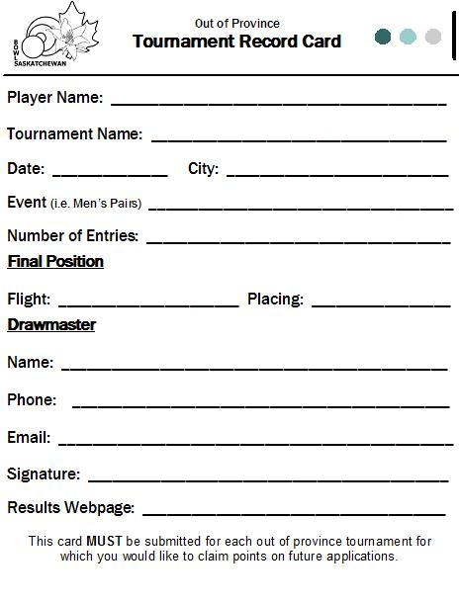
1st 2nd 3rd 4th
8 6 4 2

SASK FIRST SANCTIONED TOURNAMENTS
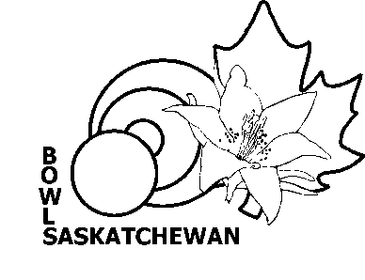

A) NATIONAL

- BILL BOETTGER MEMORIAL (Kitchener, ONTARIO)* MEN’S PAIRS

- WOBA (ONTARIO)* OPEN FOURS / SINGLES
MEN’S & WOMEN’S PAIRS
- Open National Championships – includes Singles, Junior, Forster Lang and U25 Qualifier (added Oct/15)
- B Team at a National Championships (added Oct/15)
* Kitchener and WOBA will be considered one tournament if they are all held in conjunction with one another

B) INTERNATIONAL

- U.S. OPEN (MEN/WOMEN) FOURS/TRIPLES, PAIRS & SINGLES

- ANY U.S. DIVISIONAL FOURS/TRIPLES, PAIRS & SINGLES

- THOMPSON ZIVEC (ARIZONA) * OPEN PAIRS

- ARIZONA RINKS (ARIZONA) * MIXED FOURS

- SALISBURY SINGLES (ARIZONA) * OPEN SINGLES

* The three Arizona Tournaments constitute one tournament

C) Team Canada Training Camps

NOTE: If a tournament is not on the approved list, it can be submitted for sanction consideration by the Sask First Committee. Competitor list, tournament schedule, Drawmaster name and email address, and tournament results must be submitted.

A Tournament Record Card must be filled out for every out-of-province tournament for which you will claim funding or points for future applications

