AWARDS AND RECOGNITION

AWARD OF MERIT
The Award of Merit was established to recognize continuing volunteerism by individuals and their contribution to their club over a number of years.

Clubs are asked to submit their nominations for this award by December 31st of each year.

From the nominations received, the Executive of Bowls Saskatchewan selects up to 3 members for recognition in any given year. Subsequent submissions of individuals who have not been selected in any given year may be resubmitted again. Recipients of this award are only recognized once.

Recognition from Bowls Saskatchewan is in the form of a team jacket given to the club president to be presented to the recipient at a time of the club’s choosing.
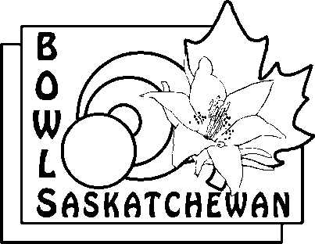
AWARD OF MERIT NOMINATION FORM

Name: _____________________

Member of Lawn Bowling Club for years.

Details regarding this individual involvement at club level such as administration, coaching, officiating, etc.

Details regarding this individual’s involvement with Bowls Saskatchewan and/or Bowls Canada Boulingrin, if any:

SPONSORS:

